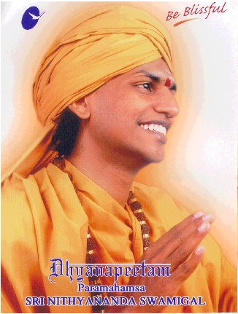

Paramahamsa
Sri Nithyananda Swamigal

Visit to NJ/NY Area

March 16-22, 2004

Program Details

Paramahamsa Sri Nithyananda Swamiji's mission is to make people aware about the importance of meditation. He says that every individual possesses the power to heal one’s self. Swamiji has formulated various meditation techniques to help in awakening this dormant power. He is contemporary in his outlook and practical in his approach, and has adopted ancient meditation techniques from various religions (Christianity, Zen Buddhism, Hinduism, Sufism, etc.).

Swamiji will be visiting New York/New Jersey area to conduct a two-day meditation program called ANANDA SPURANA PROGRAM (ASP). In addition to the two day program, Swamiji will conduct free discourses on various topics as summarized below. He will initiate disciples through meditation techniques called Ananda Healing. Details of Swamiji and ASP may be found at www.dhyanapeetam.org. More details of his tour to other cities may be found at http://www.swamisworld.com/
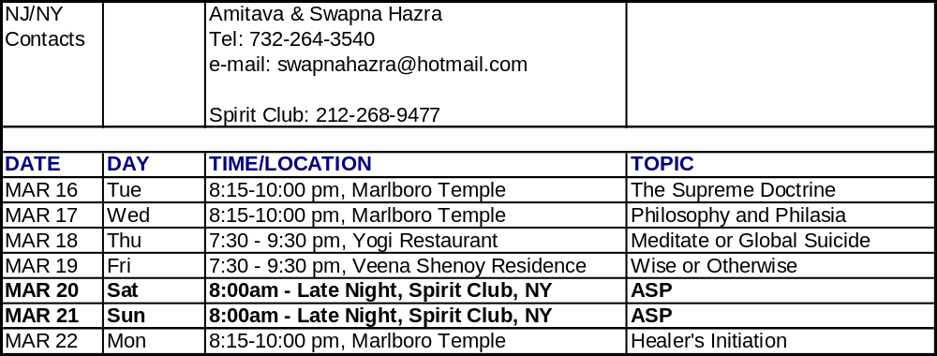

NOTE: ASP costs are $200/person. All other programs are at no cost. Attached document contains directions for various discourse locations as well as ASP location. Participants are encouraged to stay at nearby hotels close to ASP location.

Discourse Schedule:
Tuesday 3/16 - Marlboro Temple (Time 8:15 – 10:00 pm)
Wednesday 3/17 - Marlboro Temple (Time 8:15-10:00 pm)
Thursday, 3/18 - Yogi Restaurant (7:30-9:30 pm)
Friday, 3/19 - Veena and Ramnath Shenoy's residence (7:30-9:30 pm)

Marlboro Temple – Hindu American Temple & Cultural Center, 31 Wooleytown Road, Morganville, NJ 07751, Tel: 732-972-5552

From Garden State Parkway:
Take Exit 123 to Route 9 South
Travel 7 miles on Route 9 South
Go past Route 18 Junction
Take Texas Road Exit
Make a jug handle left turn to Texas Road East
Go 3 miles on Texas Roas East
Turn Right on Wooleytown Road
The Temple is on your right

From NJ Turnpike
Take Exit 9 to Rte 18 South
Travel 8 miles on Rt. 18S
Take Exit for Rte. 9 South—Freehold
Stay on extreme right. Texas Road exit is within a tenth of a mile
Make jug handle left turn on Texas Road East and follow directions indicated previously

Yogi Restaurant in Howell, NJ : address - 2450 rt 9 south, Howell Center Mall, Howell, NJ, phone - (732) 409-3500

Directions
From Route 18 or I-287 take Route 9S to get to Howell - In Howell look for Howell Center Mall on right side of road (partyfair store is a landmark in that complex). The restaurant is in the Howell Center Mall

Veena & Ramnath Shenoy's telephone no.
732-308-3954

The evening discourse for Friday 3/19 is scheduled to be at Sehnoy home in Marlboro, NJ 7:30-9:30 PM. Those needing directions can call Shenoys at the above tel #s.

ASP Location

March 20-21 ASP

Event Details: All Day
SPIRIT
542 West 27th Street,
4th Floor
New York NY 10001
Building is between 10th and 11th Ave.

Hotels in the vicinity:

- Best Western Convention Center Hotel
522 West 38th Street
New York, NY
Tel: 212-405-1700
(10 blocks from Spirit Club, 10 minute Walk)

- Signature Suite West Village
55 Morton Street
New York, NY
Tel: 212-475-4756
(10 minutes by cab)

- Hotel Stanford
43 West 32nd Street
New York, NY
Tel: 212-563-1500
(10 minutes by cab)

- Howard Johnson Inn
34th Street, Between 7th and 8th Avenue
Tel: 212-947-5050
(10 minutes by cab)

- Ramada Plaza New Yorker
34th Street, around 8th Avenue
Tel: 212-971-0101
(10 min by cab)

